**SIMPSON AND ASHLAND PARISH COUNCIL**

# 

**FINANCIAL REPORT**

**Financial Summary**

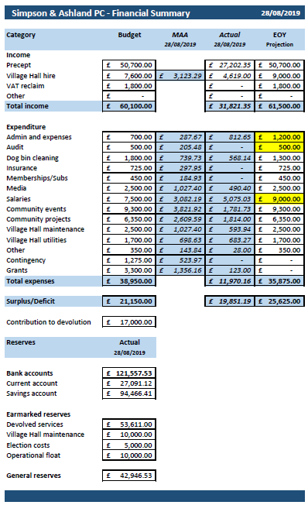

**Explanation of columns**

|  |  |
| --- | --- |
| **Category** | Category of income or expenditure. These categories have been chosen both for clarity and to enable simple calculation for the annual AGAR form |
| **Budget** | The budget for the category set at the beginning of the year |
| **MAA** | Moving Annual Average. The amount that we would have received/spent if the budgeted amount was received/spent equally across the year. This helps us to monitor whether we are over or under budget |
| **Actual** | The actual amount we have received/spent to date |
| **EOY** | The amount that we currently project we will have received/spent by the end of the year |

**Notes**

Budget categories where I am predicting overspend have been highlighted in yellow and can be explained as follows:

Admin & expenses – additional email hosting and purchase of laptop not budgeted for

Audit – additional work following queries from external auditor

Salaries – additional hours required for clerk handover

**Payments**

The following table shows all payments made from the current account between 01.07.19 and 28.08.19

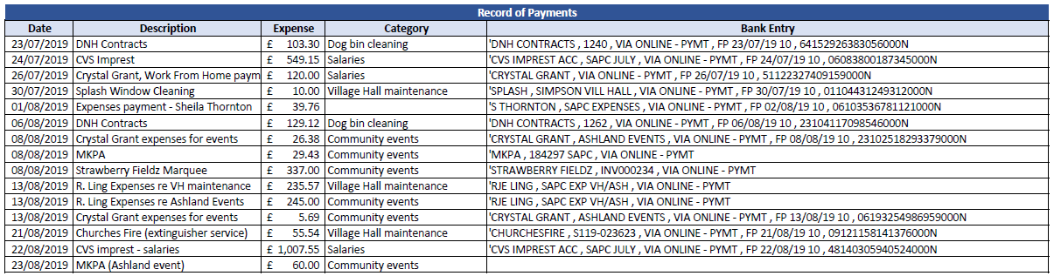

**Prepared by Lisa Emmanuel, Parish Clerk and Responsible Financial Officer, 29.10.19**